**Easy Homework VBA Script**

Sub StockDataHWEasy()

Dim ws As Worksheet

For Each ws In ThisWorkbook.Worksheets

Dim TickerName As String

Dim TickerTotal As Double

TickerTotal = 0

Dim LastRow As Long

LastRow = ws.Cells(Rows.Count, 1).End(xlUp).Row

Dim SummaryRow As Double

SummaryRow = 2

For i = 2 To LastRow

   If ws.Cells(i, 1).Value <> ws.Cells(i + 1, 1).Value Then

       TickerName = Cells(i, 1).Value

       TickerTotal = TickerTotal + Cells(i, 7).Value

       ws.Range("I" & SummaryRow).Value = TickerName

       ws.Range("J" & SummaryRow).Value = TickerTotal

       SummaryRow = SummaryRow + 1

       TickerTotal = 0

   Else

       TickerTotal = TickerTotal + Cells(i, 7).Value

   End If

Next i

ws.Range("I1").Value = "Ticker"

ws.Range("J1").Value = "Total Stock Volume"

ws.Columns("A:J").HorizontalAlignment = xlCenter

ws.Columns("A:J").EntireColumn.AutoFit

Next ws

End Sub

**Easy Screenshot**

*2016*

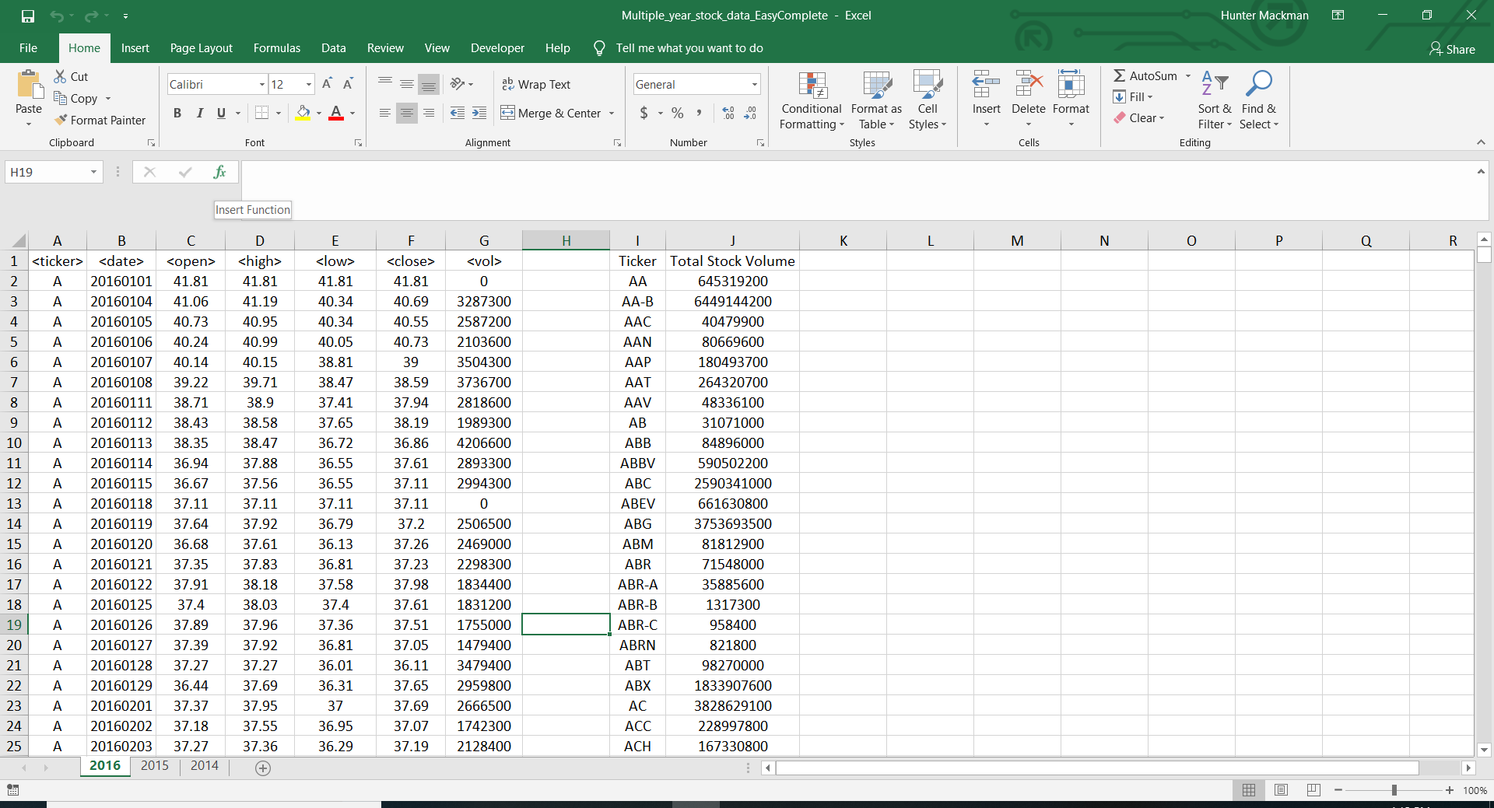

*2015*

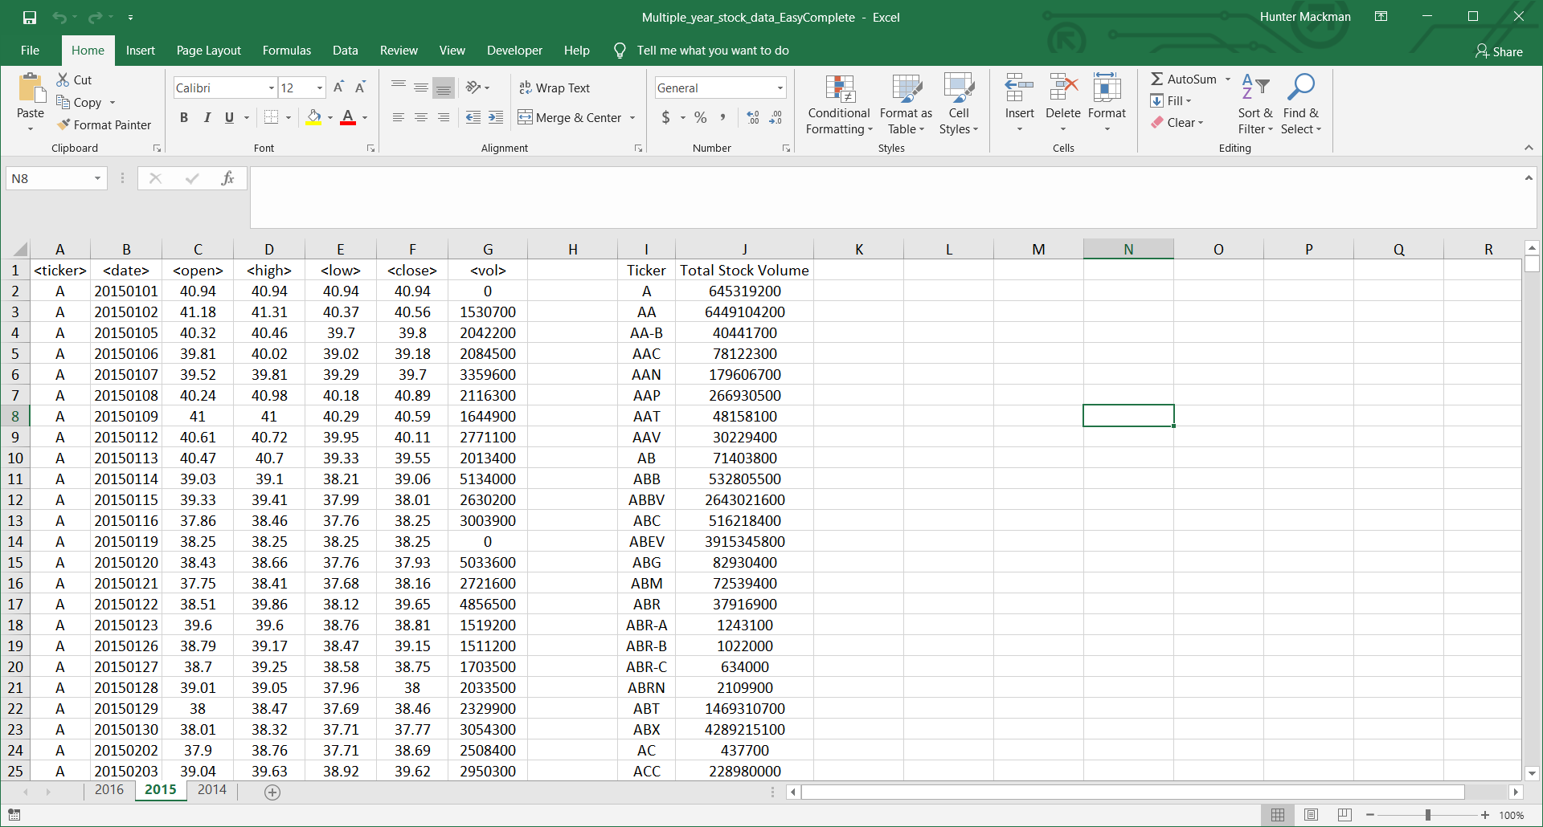

*2014*

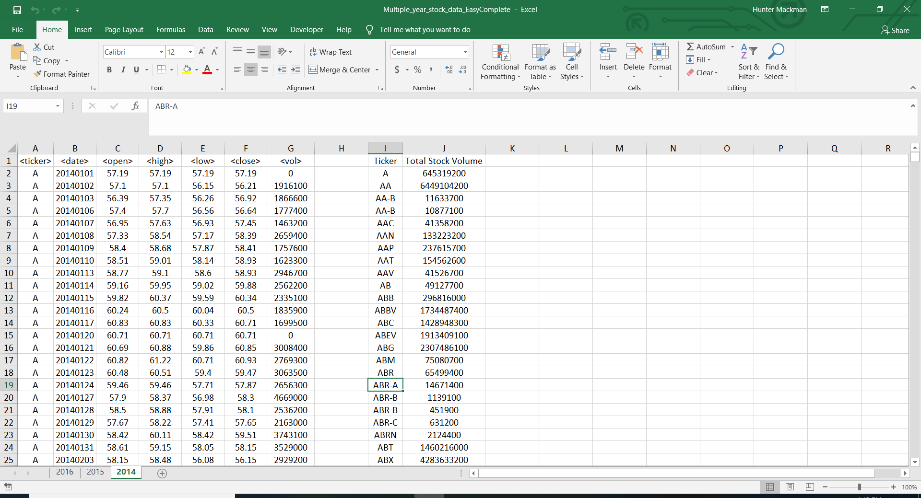

**Hard VBA Script**

Sub StockDataHWHard()

Dim ws As Worksheet

For Each ws In ThisWorkbook.Worksheets

Dim TickerName As String

Dim TickerTotal As Double

TickerTotal = 0

Dim PercentChange As Double

Dim YearlyChange As Double

Dim start As Double

start = 2

Dim LastRow As Double

LastRow = ws.Cells(Rows.Count, 1).End(xlUp).Row

Dim SummaryRow As Double

SummaryRow = 2

For i = 2 To LastRow

If ws.Cells(i, 1).Value <> ws.Cells(i + 1, 1).Value Then

TickerName = Cells(i, 1).Value

TickerTotal = TickerTotal + Cells(i, 7).Value

ws.Range("I" & SummaryRow).Value = TickerName

ws.Range("L" & SummaryRow).Value = TickerTotal

YearlyChange = (ws.Cells(i, 6)) - (ws.Cells(start, 3))

ws.Range("J" & SummaryRow).Value = YearlyChange

PercentChange = (YearlyChange) / (ws.Cells(start, 3))

ws.Range("K" & SummaryRow).Value = PercentChange

SummaryRow = SummaryRow + 1

TickerTotal = 0

start = i + 1

Else

TickerTotal = TickerTotal + Cells(i, 7).Value

If ws.Cells(start, 3).Value = 0 Then

For find_value = start To i

If ws.Cells(find_value, 3).Value <> 0 Then

start = find_value

Exit For

End If

Next find_value

End If

End If

Next i

For h = 2 To LastRow

If ws.Cells(h, 10) >= 0 Then

ws.Cells(h, 10).Interior.ColorIndex = "4"

Else

ws.Cells(h, 10).Interior.ColorIndex = "3"

End If

Next h

Dim Min As Double

Dim Max As Double

Dim Volume As Double

Max = Application.WorksheetFunction.Max(ws.Columns("K:K"))

Min = Application.WorksheetFunction.Min(ws.Columns("K:K"))

Volume = Application.WorksheetFunction.Max(ws.Columns("L:L"))

For a = 2 To LastRow

If ws.Cells(a, 11).Value = Max Then

ws.Range("O2").Value = ws.Cells(a, 9)

ElseIf ws.Cells(a, 11).Value = Min Then

ws.Range("O3").Value = ws.Cells(a, 9)

ElseIf ws.Cells(a, 12).Value = Volume Then

ws.Range("O4").Value = ws.Cells(a, 9)

Else

End If

Next a

ws.Range("P2").Value = Max

ws.Range("P3").Value = Min

ws.Range("P4").Value = Volume

ws.Range("N2").Value = "Greatest % Increase"

ws.Range("N3").Value = "Greatest % Decrease"

ws.Range("N4").Value = "Greatest Total Volume"

ws.Range("O1").Value = "Ticker"

ws.Range("P1").Value = "Value"

ws.Range("I1").Value = "Ticker"

ws.Range("L1").Value = "Total Stock Volume"

ws.Range("K1").Value = "Percent Change"

ws.Range("J1").Value = "Yearly Change"

ws.Columns("A:P").HorizontalAlignment = xlCenter

ws.Columns("A:P").EntireColumn.AutoFit

ws.Columns("K:K").Style = "Percent"

ws.Range("P2:P3").Style = "Percent"

ws.Range("P2:P3").NumberFormat = "0.00%"

ws.Columns("K:K").NumberFormat = "0.00%"

ws.Columns("J:J").NumberFormat = "0.00"

Next ws

End Sub

**Hard Screenshot**

*2016*

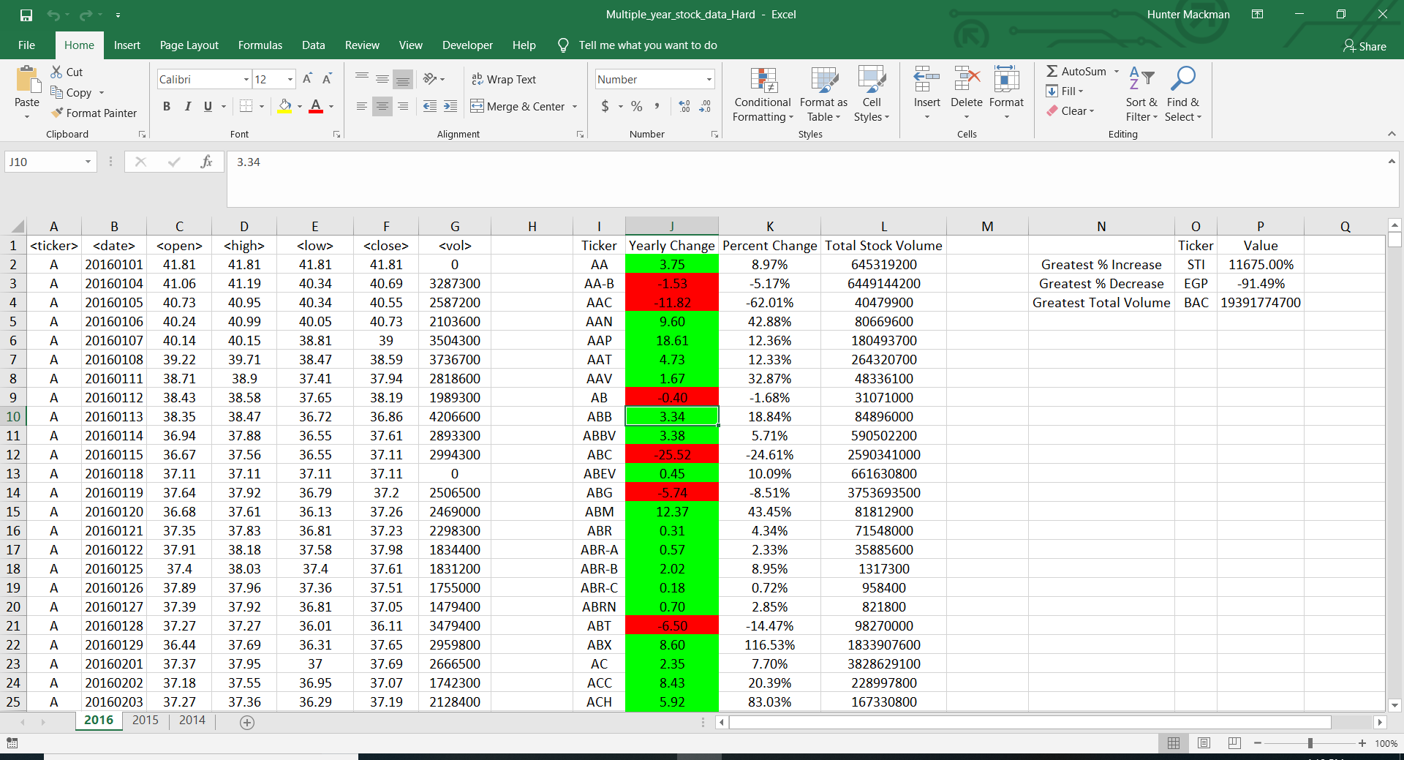

*2015*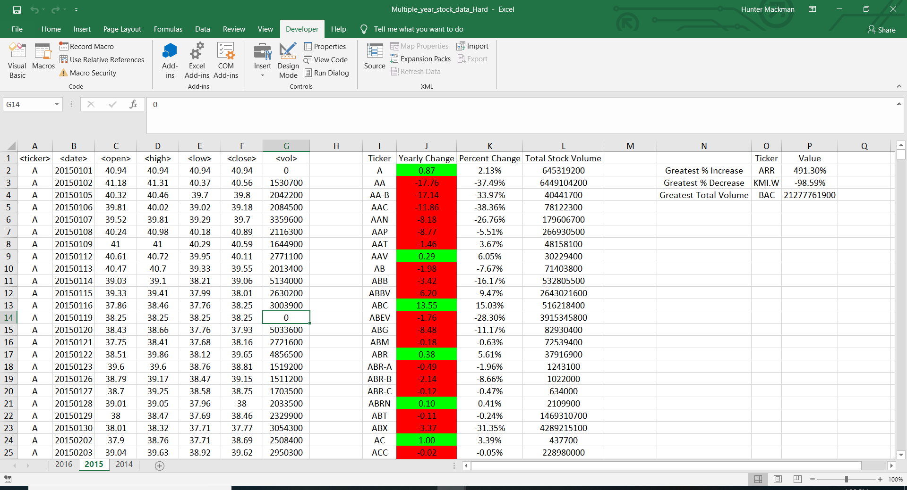

*2014*

